***ANGLES***

***Summary:***

***1. (i)*** *The space enclosed between the lines* ***AB*** *and* ***BC*** *is referred to as an angle*

***An angle***

***A***

***B***

***C***

***(ii)*** *The above angle is described as* ***∠ABC*** *or* ***∠CBA*** *or* ***∠B***

***(iii)*** *In geometry****,*** *angles are measured in degrees using a protractor*

***TYPES OF ANGLES.***

1. *An* ***acute angle*** *is an angle that is less than 900.*

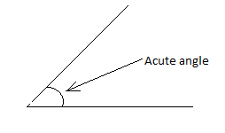

1. *A* ***right angle*** *is an angle that is equal to 900.*

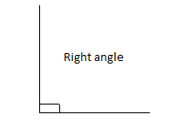

1. *An* ***obtuse angle*** *is an angle between 900 and 1800.*

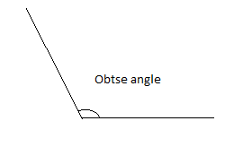

1. A **straight angle** is an angle that is equal to 1800.



1. *A* ***reflex angle*** *is an angle that lies between 1800 and 3600.*

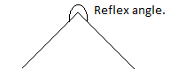

1. *A* ***full angle*** *is an angle that is equal to 3600.*

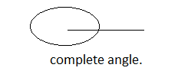

***ANGLE RELATIONSHIPS****.*

1. ***Complementary angles*** *are two angles that add up to 900. Thus 400 and 500 are complementary angles since they add up to 900.*
2. *Two angles are* ***supplementary*** *when they add up to 1800. Thus 300 and 1500 are supplementary angles since they add up to 1800.*
3. *Angles on a line add up to 1800.*

*Thus* ***x +y=1800****. *

1. *Angles around a point add up to 3600.*

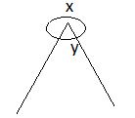

*Thus,* ***x+y=3600****.*

1. *Two angles next to each other are called* ***adjacent angles****. Thus, in this example, p and q are adjacent angles.*

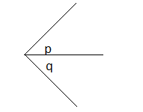

1. ***Vertically opposite angles*** *are angles opposite to each other when two lines* cross. In this example, p and q are vertically opposite angles.

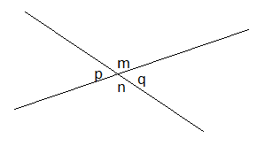

*Vertically opposite angles are equal. Thus, p=q and m=n.*

***Examples:***

1. *In the figure below, find the size of angle* ***AOC****.*

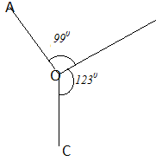

***Solution***

*If <AOC =x*

*x+990+1230=3600. (Angles around a point.)*

*x = 1380.*

1. *Find the size of each angle in the table below.*

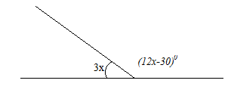

***Solution***

*3x+ (12x-30)0=1800.*

*x=140.*

*Angle 3x = 3(14) =420.*

*Angle (12x-30) = 12(14)-30 = 1380.*

1. *The figure below shows two intersecting lines.*

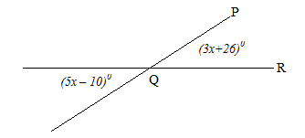

*Find the size of angle* ***PQR****.*

***Solution:***

*(5x – 10)0 = (3x+26)0. (Vertically opposite angles)*

*x = 180.*

*Angle PQR = 3(18) +26 = 800.*

1. *The figure below shows three intersecting lines.*

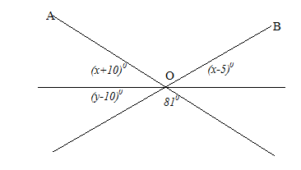

*Find the values of x and y.*

***Solution:***

*<AOC=810. (Vertically opposite angles)*

*(x+10)0+810+(x-5)0=1800 (linear angles)*

*x=470.*

*(x+10)0+(y-10)0+810=1800 (linear angles)*

*(47+10)0+y-10+81=1800*

*y=520.*

***ERR.***

1. *Find the size of two complementary angles that are such that the size of one of them is four times the size of the other.*
2. *The ratio of two complementary angles is 1:5. Find the size of each of them.*
3. *Find the size of an angle that is such that when added on to one – sixth of its complement, the result is 400.*
4. *Find the size of angle marked y in the figure below.*

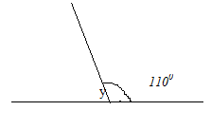

1. *Find the value of x for which the angles (2x+10)0 and (130-x)0 are vertically opposite.*
2. *The figure below shows two intersecting lines.*

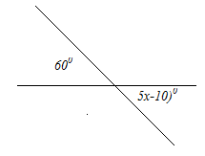

*Find the values of x.*

1. *The figure below shows three intersecting lines.*

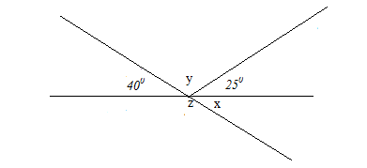

*Find the values of x, y and z.*

1. *In the figure below, find the size of reflex angle AOC.*

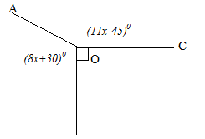

***ANGLES ON A TRANSVERSAL***

***Summary:***

1. *A line cutting across parallel lines is called a* ***transversal.***
2. *(i) Below is an illustration of the different angle formed on a transversal.*

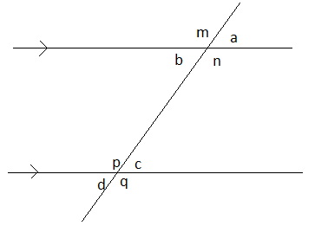

*(ii) The angles in matching corners are called* ***corresponding angles****.*

*(iii).The interior angles on the opposite sides of a transversal are called* ***co-interior******angles****.*

1. *The following are the transversal angle properties*
2. *Corresponding angles are equal. Thus <a=<c, <b=<d, <m=<p and <n=<q*
3. *Alternate angles are equal. Thus <b=<c and <n=<p.*
4. *Co-interior angles add up to* ***1800****,thus* ***b + p=1800***

***EXAMPLES:***

1. *The figure below shows parallel lines cut by a transversal.*

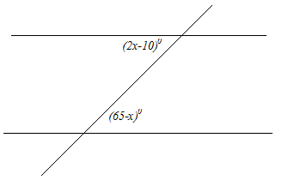

*Find the value of x.*

***Solution***

*(2x-10)0= (65-x )0 (alternate angles)*

*x=250 .*

1. *The figure below shows parallel lines cut by a transversal.*

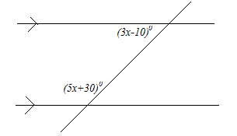

*Find the value of x*

***Solution***

*(3x-10)0+ (5x+30)0=1800 (co-interior angles)*

*x=200*

*3. The below shows parallel lines cut by transversal*

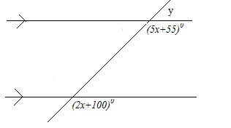

*Find the size of the angle marked y*

***Solution***

*(5x+55)0= (2x+100)0 (corresponding angles)*

*x=150*

*y+ (5x+55) =180*

*y+5(15) +55=180*

*y=500*

1. *The figure below shows parallel lines cut by a transversal*

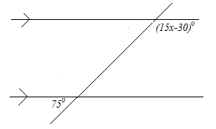

*Find the value of x*

***Solution***

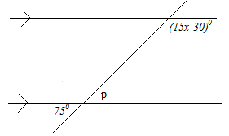

*<p=750 (vertically opposite angles)*

*750 + (15x-30)0=1800*

*x=90.*

1. *The figure below shows parallel lines AB and CD.*

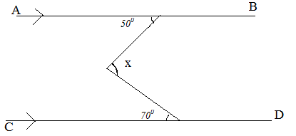

*Find the size of angle marked x.*

***Solution***

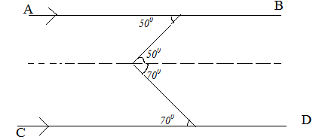

*X=500+700*

*X=1200.*

1. *The figure below shows parallel lines AB and CD.*

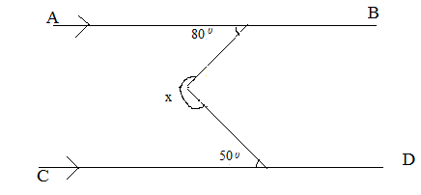

*Find the size of the angle marked x.*

*Solution*

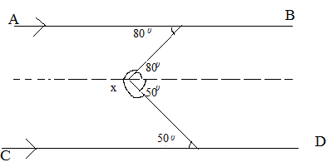

*x+800+500=3600 (angles around a point)*

*x = 2300.*

1. *The figure below shows parallel lines AB and CD.*

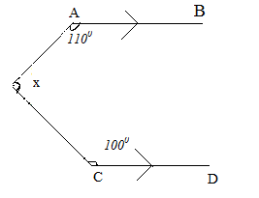

*Find the size of the angle marked x.*

***Solution***

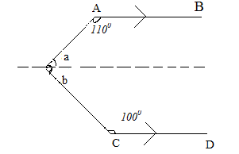

*a+1100=1800 (co-interior angles)*

* a=700*

*b+1000=1800*

*b=800*

***EER***

1. *The figure below shows parallel lines cut by a transversal.*

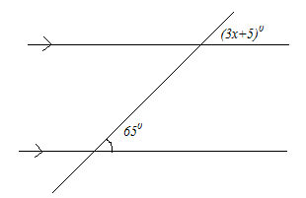

*Find the value of x.*

1. *The figure below shows parallel lines cut by a transversal.*

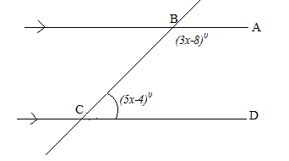

*Find the size of angle ABC and angle BCD.*

1. *The figure below shows parallel lines cut by a transversal.*

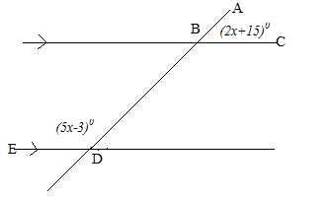

*Find the size of angle ABC and angle BDE.*

1. *The figure below shows parallel lines cut by a transversal.*

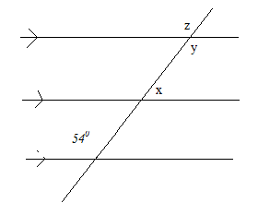

*Find the values of x, y and z.*

1. *The figure below shows parallel lines cut by a transversal.*

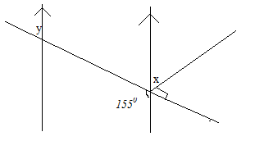

*Find the values of x and y.*

1. *The figure below shows parallel lines AB and CD.*

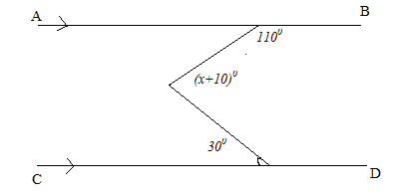

*Find the value of x.*

1. *The figure below shows parallel lines AB and CD.*

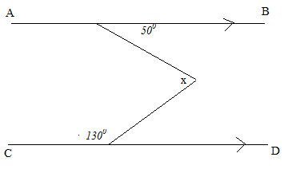

*Find the value of x.*

1. *The figure below shows parallel lines AB and CD.*

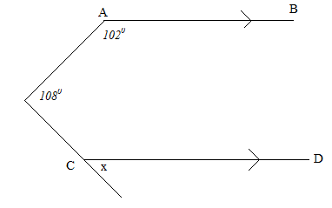

*Find the value of x.*

1. *The figure below shows parallel lines AB, CD and EF.*

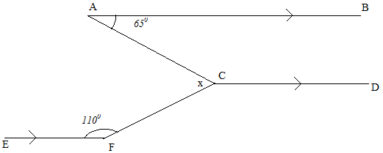

*Find the value of x.*

1. *The figure below shows parallel lines AB and CD.*

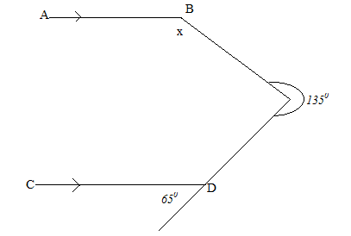

*Find the value of x.*

1. *The figure below shows parallel lines AB and CD.*

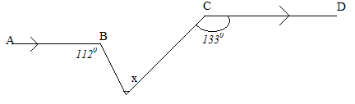

*Find the value of x.*

***DIRECTION AND BEARINGS***

***Summary:***

***(i)*** *Bearings are used to show the direction of one point relative to another*

***(ii)*** *The four main directions of a compass are North* ***(N),*** *East* ***(E),*** *South* ***(S)*** *and West* ***(W)***

***(iii)*** *A directional compass is as follows****:***

***(iv)*** *The bearing to a point is the angle measured in a clockwise direction from the north line.*

***(v)*** *Bearings are stated using three digits. Thus* ***5°*** *is written as* ***005°***

***(vi)*** *The north line represents a bearing of* ***000°***

***(vii)*** *The bearing of* ***N60°E*** *means an angle of* ***60°*** *measured from* ***N*** *towards* ***E***

***EXAMPLES:***

***1.*** *The bearing of point* ***P*** *from point* ***Q*** *is* ***060°.*** *Find the bearing of* ***Q*** *from* ***P***

***2.*** *The bearing of point* ***N*** *from point* ***M*** *is* ***310°.*** *Find the bearing of* ***M*** *from* ***N***

***3.*** *Find the angle between the direction* ***N70°E*** *and* ***S70°W***

***4.*** *A boat sails* ***15km*** *on a bearing of* ***000°.*** *It then sails* ***8km*** *due East****.*** *Calculate how far it is from the starting point*

***5.*** *Two ships* ***P*** *and* ***Q*** *leave port* ***K*** *at the same time****. P*** *sails* ***9km*** *on a bearing of* ***030°*** *and* ***Q*** *sails* ***12km*** *on a bearing of* ***120° .*** *Calculate how far apart are the ships*

***6.*** *An observer at point* ***P*** *sees an object on a bearing of* ***100°.*** *Another observer at point* ***Q*** *sees the same object on a bearing of* ***150°.*** *Given that the distances of the object from* ***P*** *and* ***Q*** *are equal****,*** *determine the bearing of* ***P*** *from* ***Q***

***Soln:***

***View from P View from Q***

***Combined View***

*If* ***x + x + 50° = 180°*** *“Isosceles triangle”*

*⇒* ***x = 65°***

***∴ Required bearing =*** *150° + x* ***=*** *150° + 65°* ***= 215°***

***7.*** *A plane flies* ***300km*** *from airport* ***A*** *to airport* ***B*** *on a bearing of* ***0600.*** *It then flies* ***450km*** *to airport* ***C*** *on a bearing of* ***1500 .***

***(a)*** *Use a scale of* ***1cm*** *to represent* ***50km,*** *make a scale drawing to*

*show the route of the plane.*

***(b)*** *Find the distance and bearing of airport* ***A*** *from* ***C.***

***(c)*** *If the plane flies directly back to* ***A*** *at a speed of  determine how*

*long it takes to fly back to* ***A.***

***8.*** *Town* ***Q*** *is on a bearing of* ***0600*** *from Town* ***P*** *and* ***120 km*** *away****.*** *Town* ***R*** *is on a*

*bearing of* ***1300*** *from* ***P*** *and* ***2200*** *from* ***Q.***

***(a)*** *By scale drawing show the relative positions of* ***P, Q*** *and* ***R.***

***[*** *Use a scale of* ***1cm*** *to represent* ***20km******]***

***(b)*** *Find the distance between****:***

***(i) P*** *and* ***R***

***(ii)******Q*** *and* ***R***

***(c)*** *A plane flies from town* ***R*** *on a bearing of* ***2100*** *at a speed of *

*After* ***40*** *minutes of flying, the pilot decides to fly directly to town* ***P.*** *Find the*

*time it would take to reach* ***P*** *and the bearing to which it would fly*

***9.*** *A plane flies on a bearing of* ***0600*** *from airport* ***A*** *to airport* ***B*** *at a steady speed*

*of* ***200kmh-1*** *for* ***2hours.*** *It then flies on a bearing of* ***1500*** *to air strip* ***C*** *at the*

*same original speed for*

***(a)*** *Use a scale of* ***1cm*** *to represent* ***50km,*** *construct a scale drawing*

*to show the route of the plane.*

***(b)*** *Find the distance and bearing of* ***A*** *from* ***C.***

***(c)*** *If the plane flies directly back to* ***A*** *at a speed of  determine how*

*long it takes to fly back to* ***A.***

***EER:***

***1.*** *A ship sails* ***10km*** *due north and then* ***24km*** *due east****.*** *Calculate how far it is from the starting point*

***2.***  *A man walks from town* ***P 9 km*** *due north then* ***12km*** *due east to town* ***Q.*** *Calculate the distance of* ***P*** *from* ***Q***

***3.*** *Find the angle between the direction* ***N450°E*** *and* ***S25°W***

***4.*** *A ship sails equal distances due South−East and then due South−West to end up* ***14km*** *due South of its starting point****.*** *Calculate how long is each part of its journey*

***5.*** *The bearing of* ***P*** *and* ***Q*** *from* ***A*** *are* ***200°*** *and* ***290°*** *respectively. Given that distance* ***AP = 5⋅6km*** *and* ***AQ = 4⋅7km,*** *find by scale drawing the****:***

***(i)*** *distance* ***PQ***

***(ii)*** *bearing of* ***P*** *from* ***Q***

***6.*** *A plane flies from airport* ***K*** *due North for* ***350km*** *to airport* ***R.*** *It then flies on a*

*bearing of* ***295°*** *for* ***250km*** *to air strip* ***N.*** *From there it flies on a bearing of*

***0900*** *for* ***500km*** *to air strip* ***M.***

***(a)*** *Use a scale of* ***1cm*** *to represent* ***50km,*** *draw an accurate diagram*

*to show the route of the plane.*

***(b)*** *Find the distance and bearing of* ***K*** *from* ***M.***

***(c)*** *If the plane flies directly back to* ***K*** *at a speed of  determine how*

*long it takes to fly back to* ***K.***

***7.*** *Town* ***B*** *is* ***100km*** *away from town* ***A*** *on a bearing of* ***135°.***  *Town* ***D*** *is* ***124km***

*away from town* ***B*** *on a bearing of* ***090°.***  *Town* ***C*** *is* ***160km*** *away from town* ***D***

*on a bearing of* ***030°.***

***(a)*** *Use a scale of* ***1cm*** *to represent* ***20km,*** *draw an accurate diagram to show the*

*relative positions of the towns.*

***(b)*** *Find the****:***

***(i)*** *distance and bearing of* ***C*** *from* ***A***

***(ii)*** *distance and bearing of* ***B*** *from* ***C***

***8.*** *A plane flies due west from airport* ***A*** *to airport* ***B*** *at a steady speed*

*of******1*** *for It then alters its course and flies North−West to air*

*strip* ***C*** *at  From there it flies on a bearing of* ***0600*** *to air strip* ***D*** *at*

* for The total time of flight between the four air strips is*

**

***(a)*** *By scale drawing****,*** *determine the distance and bearing of* ***A*** *from* ***D***

***[*** *Use a scale of* ***1cm*** *to represent* ***20km******]***

***(b)*** *Find the average speed for the journey from* ***A*** *to* ***D.***

***(c)*** *If the plane flies directly back to* ***A*** *at a speed of  determine how*

*long it takes to fly back to* ***A.***

***9.*** *A boat sails* ***450km*** *from island* ***M*** *to island* ***X*** *on a bearing of* ***0800*** *at a speed*

*of  It then sails on a bearing of* ***2000*** *to island* ***Y*** *at the same original*

*speed for* ***3*** *hours****.*** *From there it sails at a speed of  to island* ***Q***

*which is west of* ***M*** *and* ***400km*** *away from it****.***

***(a)*** *Use a scale of* ***1cm*** *to represent* ***50km,*** *draw an accurate diagram*

*to show the route of the boat.*

***(b)*** *Find the distance and bearing of* ***Q*** *from* ***Y.***

***(b)*** *Find the****:***

***(i)*** *total time the boat takes to cover the whole journey*

***(ii)*** *average speed of the boat for the whole journey* ***.***

***10.*** *In a sports field****,*** *four points* ***A, B, C*** *and* ***D*** *are such that* ***B*** *is due south of A*

*and due west of* ***D. AB = 10⋅8m, BD = 18⋅8m, CD = 16⋅6m, ∠BDA = 60°,***

***∠CDB = 40°*** *and* ***∠BCD = 80°.***

***(a)*** *Use a scale of* ***1cm*** *to represent* ***2m,*** *draw an accurate diagram to show the*

*the relative positions of the points.*

***(b)*** *Find the****:***

***(i)*** *distances* ***BC*** *and* ***AD***

***(ii)*** *bearing of* ***B*** *from* ***C.***

***(c)*** *If an athlete runs from point* ***A*** *through* ***B, C, D*** *and back to* ***A*** *in* ***16 seconds,***

*find the athlete’s average speed*

***11.*** *The bearing of tower* ***A*** *from point* ***O*** *is* ***060°*** *and that of tower* ***B*** *from* ***O,*** *is*

***200°.***  *Given that distance* ***OA = 24km,******OB = 33km*** *and tower C is exactly half*

*way between towers* ***A*** *and* ***B,***

***(a)*** *Use a scale of* ***1cm*** *to represent* ***5km,*** *draw an accurate diagram to show the*

*relative positions of the towers.*

***(b)*** *Find the****:***

***(i)*** *distances* ***AB*** *and* ***OC***

***(ii)*** *bearing of* ***B*** *from* ***A***

***(iii)*** *bearing of* ***C*** *from* ***O***

***(c)*** *Find****:***

***(i)*** *the average speed of the cyclist who takes to travel*

*directly from* ***A*** *to* ***O***

***(ii)*** *how long it takes another cyclist to travel from* ***A*** *to* ***B*** *via* ***O*** *at a*

*speed of faster than that of the cyclist in* ***(c) (i)*** *above*

***12.*** *A plane left airport* ***K*** *at* ***0600*** *hours and flew on a bearing of* ***090°*** *at a speed*

*of  It landed at airport* ***R*** *at* ***0830*** *hours. At exactly* ***0900*** *hours****,*** *it*

*left* ***R*** *and flew on a bearing of* ***340°,*** *at the same original speed. It then landed*

*at airport* ***M*** *at* ***1200*** *hours*

***(a)*** *Use a scale of* ***1cm*** *to represent* ***100km,*** *draw an accurate diagram*

*to show the route of the plane.*

***(b)*** *Find the****:***

***(i)*** *distance of* ***M*** *from* ***K (ii)*** *bearing of* ***K*** *from* ***M***

***13.*** *A rally car travels from point* ***R*** *to point* ***S*** *which is* ***260km*** *away on a*

*bearing of* ***060°*** *from* ***R.*** *The car is then set off from* ***S*** *at* ***9:30 am*** *towards*

***T*** *at an average speed of  where it is expected to reach at*

***11:30 am.*** *After travelling for one hour and twenty minutes, it broke down at*

***P.*** *The bearing of* ***T*** *and* ***P*** *from* ***S*** *is* ***300°.***

***(a)*** *Using a scale of* ***1cm:40km,*** *show positions of points* ***R, S, P*** *and* ***T***

***(b)*** *Determine the****:***

***(i)*** *distance from* ***R*** *to* ***P***

***(ii)*** *bearing of* ***P*** *from* ***R***

***(c)*** *Given that the repair took ten minutes and later the car is set off to*

*complete the journey to* ***T****. Find the speed at which the car must be*

*driven to reach* ***T*** *on time.*

***EER: S⋅3 WORK***

***1.*** *A boat sails* ***15km*** *on a bearing of* ***000°.*** *It then sails* ***8km*** *due East****.*** *Calculate the distance and bearing of the ship from its starting point*

***2.*** *Two ships set off from port* ***P*** *at the same time****.*** *One ship sails* ***8km*** *on a*

*bearing of* ***030°*** *to reach point* ***Q*** *and the other ship sails* ***15km*** *on a bearing*

*of* ***120°*** *to reach point* ***R.*** *Calculate the****:***

***(i)*** *distance and bearing of* ***R*** *from* ***Q***

***(ii)*** *area of the figure bounded by* ***P QR***

***3.*** *Two ships set off from port* ***P*** *at the same time****.*** *One ship sails* ***70km*** *on a*

*bearing of* ***050°*** *to reach point* ***Q*** *and the other ship sails* ***150km*** *on a bearing*

*of* ***110°*** *to reach point* ***R.***

***(a)*** *Calculate the****:***

***(i)*** *distance and bearing of* ***R*** *from* ***Q***

***(ii)*** *area of the figure bounded by* ***P QR***

***(b)*** *If both ships take* ***t*** *hours to reach their destination and the speed of the*

*faster ship is  find the****:***

***(i)*** *value of* ***t***

***(ii)*** *speed of the slower ship*

***4.*** *A man walks from town* ***P 9 km*** *due north then* ***12km*** *due east to town* ***Q.*** *Calculate the distance and bearing of* ***P*** *from* ***Q***

***5.*** *Port* ***B*** *is* ***25 km*** *east of port* ***C****. A navigator observes that the bearing of* ***C*** *from*

*his ship is* ***310º*** *and that of* ***B*** *is* ***018º.***

***(a)*** *Calculate the****:***

***(i)*** *distance and bearing of the ship from* ***B***

***(ii)*** *distance and bearing of the ship from* ***C***

***(b)*** *If the ship begins to sail at a speed of* ***10 kmh-1*** *on the bearing of* ***240º****,*

*determine the distance and bearing of the ship from* ***C*** *after* ***48 minutes.***

***TRIANGLES***

***Summary:***

1. *In any triangle:*
2. *The three angles add up to 1800.*
3. *The exterior angle is equal to the sum of the two opposite interior angles.*
4. *The largest angle is always opposite to the longest side.*
5. *The smallest angle is always opposite to the shortest side.*
6. *In an equilateral triangle:*
7. *All the three sides are equal in length.*
8. *The size of each angle is 600.*
9. *There are three lines of symmetry.*
10. *In an isosceles triangle:*
11. *Two of its sides are equal.*
12. *The angles opposite to the equal sides are equal.*
13. *There is one line of symmetry.*
14. *In a scalene triangle:*
15. *All the three sides are un-equal.*
16. *All the three angles are un-equal.*
17. *There is no line of symmetry.*
18. *In a right angled triangle:*
19. *One of the angles is 900.*
20. *The three sides are related by Pythagoras property* ***a2+b2=c2.***
21. *In an acute angled triangle, all the angles acute.*
22. *In an obtuse angled triangle, one of its angles is obtuse.*

***EXAMPLES:***

1. *If two angles of a triangle are 450 and 750, find the size of third angle.*
2. *The angles of a triangle are (x+370), (2x+150) and (3x+80). Find the:*
3. *value of x.*
4. *size of each angle.*
5. *If the angles of a triangle are in the ratio 3:4:5, find all the angles.*
6. *Find the angles marked with letters in the diagrams below:*

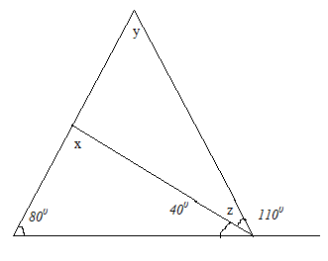

1. 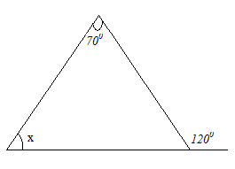
2. 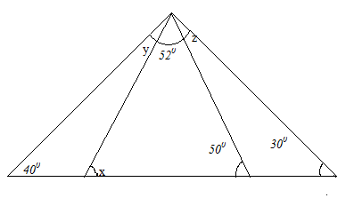
3. 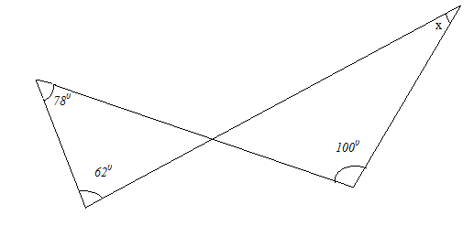
4. 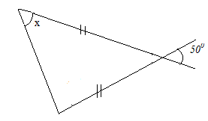

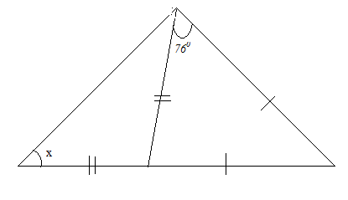

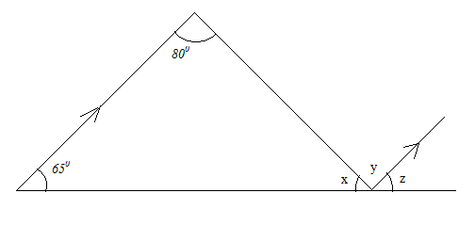

1. 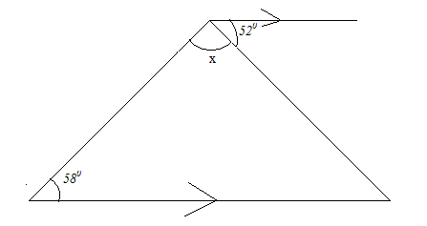
2. 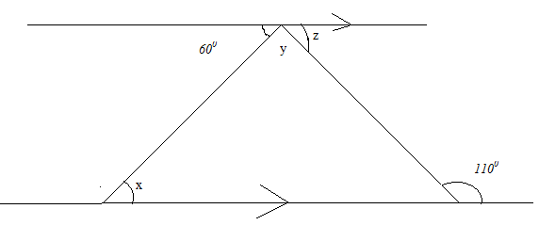
3. 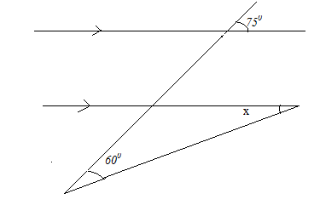
4. 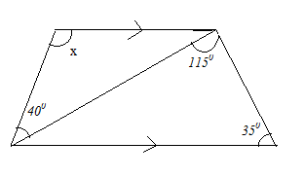
5. *A ladder of length 13m rests against a vertical wall with its floor 5m away from the wall. Find how far up the wall does the ladder reach.*
6. *Find the diagonal of a rectangle of length 8cm and width 6cm.*
7. *A square has diagonals of length 10cm. Find the sides of a square.*
8. *A cone has base radius 8cm and slant height 17cm. Find its vertical height.*
9. *Find the length of each side of an equilateral triangle whose height is 15cm.*
10. *Two buildings 24m apart are 39m and 32m tall. Find the distance between their tops.*
11. *Find the length of a diagonal of a rectangular box of length 12cm, width 9cm and height 8cm.*
12. *Find the area of a triangle whose sides are 13cm, 24cm and 13cm.*

***EER***

*1. The angles of a triangle are (5x-170), (3x+200) and (2x-130). Find the size of each angle.*

*2. The vertical angle of an isosceles triangle is 580. Find the base angles.*

*3. Find the angles of an isosceles triangle if the vertical angle is thrice the base angles.*

*4. In the diagram below, PQ is parallel to RS. 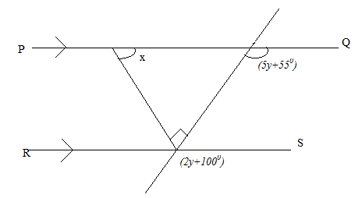*

*Find the angle marked x.*

1. *In the diagram, ABC is an equilateral triangle.*

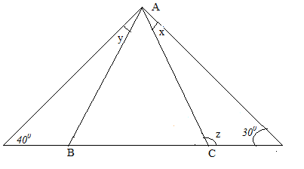

*Find the size of angles marked x, y and z.*

1. *In the figure below, PQ is parallel to RS.*

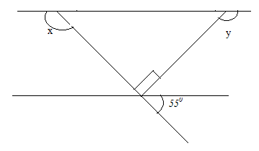

1. *Find the angles marked with letters in the figures below:*
2. 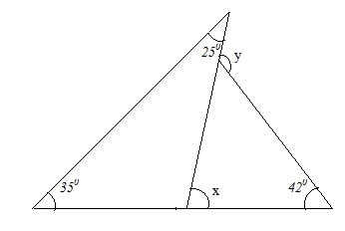

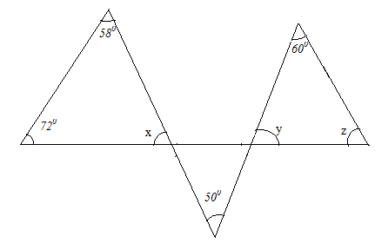

1. 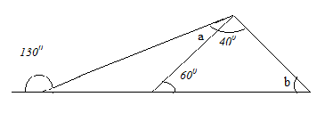
2. 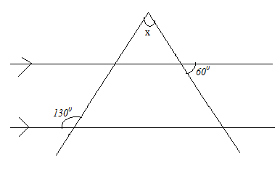
3. 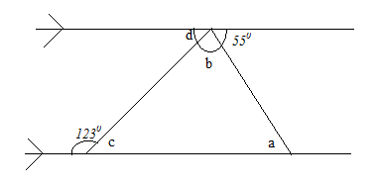
4. 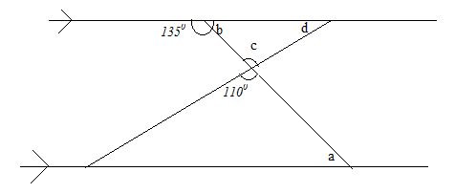

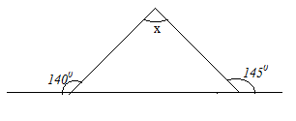

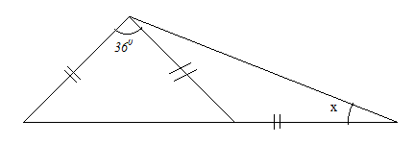

2. 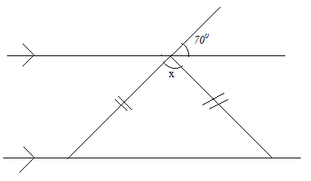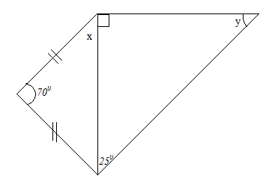
3. *In the figure below, QS is the bisector of angle PQR.*

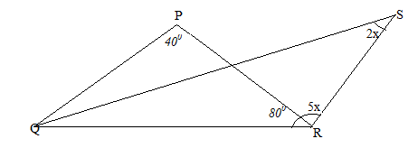

*Find the value of x, hence find the angles 2x and 5x.*

1. *In the figure below, find the length of the side marked x.*

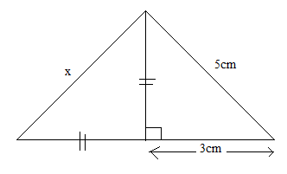

1. *Find the perimeter of a rectangle whose length is 150cm and its diagonal is 170cm long.*
2. *Find the perimeter of an isosceles triangle whose base is 16cm and its area is 240cm2.*
3. *In the figure below, find the length of CD.*

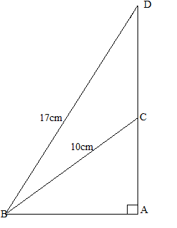

1. *In the figure below, find the lengths PR and PQ.*

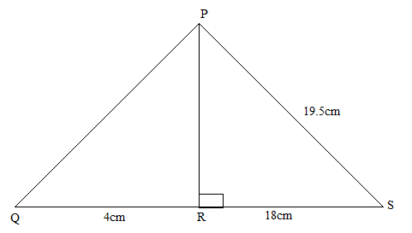

***GEOMETRIC CONSTRUCTION***

***Summary***

1. *In construction, we draw angles, lines and shapes using a ruler, pencil and pair of compasses only.*
2. *The angle bisector method can be used to create other angles. Thus, an angle of 450is obtained by bisecting an angle of 900.*
3. *The supplementary angle construction method can be used to get obtuse angles. Thus, an angle of 1200 is obtained by constructing an angle of 600.*
4. *The construction below shows how to draw a perpendicular bisector of a given line segment AB.*

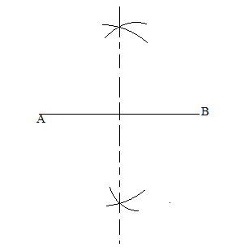

1. *The construction below shows how to draw a perpendicular to the line AB from a given external point P.*

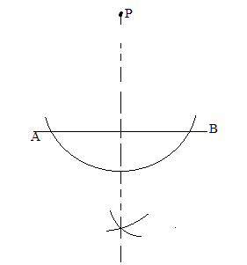

1. *The steps for constructing a circle inscribed in a triangle are as follows:*
2. *Construct angle bisectors of a triangle to meet at the centre of the circle.*
3. *Construct a perpendicular from the centre point to one side of the triangle.*
4. *Place the compass at the centre point and adjust its length up to where the perpendicular crosses the triangle, and then draw the inscribed circle.*
5. *The steps for circumscribing a circle on a triangle are as follows:*
6. *Construct the perpendicular bisectors of the two sides of the triangle to meet at the centre point of the circle.*
7. *Place the compass at the centre point and adjust its length up to any vertex of the triangle, the draw the circumscribed circle.*

***EXAMPLES:***

1. *Using a pencil, ruler and pair of compasses only, construct the following angles:*
2. *900 (ii) 450 (iii)  (iv) 1350 (v) 600*

*(vi) 300 (vii) 150 (viii)  (ix) 1500 (x) 1650.*

*(xi) 750 (xii) 82.50 (xiii) 1050.*

***1. (a)*** *Using a ruler and a pair of compasses only****,*** *construct a triangle* ***ABC*** *in*

*which* ***AB = 6⋅8cm,*** ***AC = 5⋅5cm*** *and* ***BC = 4⋅8cm.*** *Measure angle* ***ABC***

***(b)*** *Draw a perpendicular from* ***C*** *onto* ***AB*** *to meet it at* ***D.*** *Measure length* ***CD***

***(c)*** *Draw an inscribed circle of triangle* ***ABC.***  *Measure the radius of the circle*

***(d)*** *Calculate the area enclosed between the inscribed circle and the sides of the*

*triangle* ***ABC.***

***2. (a)*** *Using a ruler, pencil and a pair of compasses only****,*** *construct a triangle* ***ABC*** *such that* ***AB = 8⋅8cm,*** *angle* ***BAC = 75°*** *and angle* ***ABC = 45°.*** *Measure length* ***AC***

***(b)*** *Draw a perpendicular from* ***C*** *onto* ***AB*** *to meet it at* ***D.*** *Measure length* ***CD***

***(c)*** *Draw an inscribed circle of triangle* ***ABC.***  *Measure the radius of the circle*

***(d)*** *Calculate the area enclosed between the inscribed circle and the sides of the*

*triangle* ***ABC.***

***3. (a)*** *Using a ruler and a pair of compasses only****,*** *construct a triangle* ***ABC*** *in*

*which* ***BC = 7⋅2cm,*** ***AC = 8⋅4cm*** *and angle* ***ABC = 75°.*** *Measure length* ***AB***

*and angle* ***ACB***

***(b)*** *Draw a perpendicular from* ***A*** *onto* ***BC*** *to meet it at* ***D.*** *Measure length* ***AD***

***(c)*** *Draw a circle circumscribing triangle* ***ABC.***  *Measure the radius of the*

*circle*

***(d)*** *Calculate the area of the segments cut off by triangle* ***ABC.***

***4. (a)*** *Using a ruler and a pair of compasses only****,*** *construct a triangle* ***ABC*** *in*

*which* ***AB = 5⋅6cm, BC = 6⋅2cm*** *and angle* ***ABC=135°.*** *Measure length* ***AC*** *and angle* ***BCA.***

***(b)*** *Draw a perpendicular from* ***C*** *to meet* ***AB*** *produced at* ***D.***

***(c)*** *Construct a circle circumscribing triangle* ***BCD*** *and state its radius.*

***(d)*** *Calculate the area of the segments cut off by triangle* ***BCD.***

***5. (a)*** *Using a ruler, pencil and a pair of compasses only****,*** *construct a triangle* ***ABC*** *such that* ***AB = 8⋅6cm,*** *angle* ***BAC = 60°*** *and angle* ***ABC = 45°.***

***(b) D*** *is a point on the opposite side of* ***AB*** *as* ***C*** *such that* ***AD = BD*** *and*

***CD = 11cm.*** *Draw a circle through the points* ***A, B*** *and* ***D.*** *Measure the****:***

***(i)*** *length of* ***AC*** *and angle* ***ABD***

***(i)*** *radius of the circle*

***Soln***

***(b) HINT:*** *Triangle* ***ABD*** *must be isosceles****.*** *Thus point* ***D*** *lies on the perpendicular bisector of* ***AB***

***6.*** *Using a ruler and pair of compasses only****;***

***(i)*** *Construct a parallelogram* ***ABCD*** *such that* ***AB=6cm, BC=4⋅8cm*** *and*

*angle* ***ABC = 150°.***

***(ii)*** *Draw a perpendicular from* ***D*** *onto* ***AB*** *to meet it at* ***M.*** *Measure the*

*length* ***DM.*** *Hence find the area of the parallelogram* ***ABCD.***

***(iii)*** *Draw a circle through the points* ***M, A*** *and* ***D.*** *Measure the radius of the*

*circle*

***7.*** *Using a ruler and pair of compasses only****,*** *construct****:***

***(i)*** *a quadrilateral* ***PQRS*** *such that* ***QR = 4⋅5cm, RS =6cm, SP = 7⋅5cm,***

***PQ = 10⋅5cm*** *and angle* ***QRS = 45°.***

***(ii)*** *point* ***T*** *on* ***RQ*** *produced such that* ***PT = ST.*** *Join the points* ***P, S*** *and* ***T.***

*Measure length* ***PT*** *and angle* ***PTS.***

***(iii)*** *a circle through the points* ***P, T*** *and* ***R.*** *Measure the radius of the circle*

***8. (a)*** *Using a ruler, pencil and a pair of compasses only****,*** *construct a triangle* ***ABC*** *such that* ***AB = 6cm, AC = 8cm*** *and angle* ***BAC = 30°.***

***(b) S*** *is a point on the opposite side of* ***AC*** *as* ***B*** *such that* ***AS = SC*** *and*

***BS = 8cm.****Measure length* ***AS*** *and angle* ***ABS***

***(c) (i)*** *On the same side of* ***BS*** *as* ***C,*** *construct the locus of a point* ***K*** *such that its*

*distance from* ***BS*** *is the same as the distance of* ***C*** *from* ***BS***

***(ii)*** *Given further that angle* ***BKS = 90°,*** *find by construction two possible*

*positions* *and*  *of point* ***K.*** *Measure length *

***Soln***

***(b) HINT:*** *Triangle* ***ACS*** *must be isosceles****.*** *Thus point* ***S*** *lies on the perpendicular bisector of* ***AC***

***(c) (i) HINT:*** *The locus of* ***K*** *is a line through* ***C*** *and parallel to* ***BS.***

***(ii)*** *Since* ***∠BKS = 90°, K*** *must lie on the semi−circle with* ***BS*** *as diameter*

***EER:***

***1. (a)*** *Using a ruler, pencil and pair of compasses only, construct a triangle* ***ABC***

*such that* ***AB = 7⋅5cm*** *and* ***AC = 11⋅4cm*** *and angle* ***ABC = 120°.***

***(b)*** *Construct a perpendicular from* ***C*** *to meet* ***AB*** *produced at* ***D.***

***(c)*** *Draw a circle circumscribing triangle* ***BCD.*** *Hence calculate the area of the*

*circle to* ***2*** *decimal places****.***

***2. (a)*** *Using a ruler, pencil and a pair of compasses only****,*** *construct a triangle* ***ABC*** *such that* ***AB = 9⋅7cm, BC = 8⋅6cm*** *and angle* ***BAC = 60°.***

***(b) D*** *is a point on the opposite side of* ***AB*** *as* ***C*** *such that angle* ***ABD = 45°***

*and* ***CD = 10⋅4cm.*** *Draw a circle through the points* ***B, C*** *and* ***D.*** *Measure*

*length* ***AC*** *and the radius of the circle*

***3. (a)*** *Using a ruler and a pair of compasses only****,*** *construct a triangle* ***ABC*** *in*

*which* ***AB = BC = 6⋅8cm*** *and angle* ***ABC=120°.*** *Measure length* ***AC*** *and angle* ***BCA.***

***(b)*** *Draw a perpendicular from* ***C*** *to meet* ***AB*** *produced at* ***O.***

***(c)*** *Construct a circle circumscribing triangle* ***BOC*** *and state its radius.*

***(d)*** *Calculate the area of the segments cut off by triangle* ***BOC.***

***44. (a)*** *Using a ruler and a pair of compasses only, construct a quadrilateral* ***ABCD*** *in*

*which* ***AB = 5cm, BC = 6cm, CD = 9cm*** *and angle* ***BCD = 1350***

***(b)*** *Construct a perpendicular from* ***D*** *to meet* ***BC*** *produced at* ***M.***

***(c)*** *Construct a circumcircle of triangle* ***CDM*** *and determine the****:***

***(i)*** *length of* ***AD***

***(i)*** *radius of the circle*

***45. (a)*** *Using a ruler and a pair of compasses only, construct a quadrilateral*

***ABCD*** *in which* ***AB = 7cm, BC = 6cm, AD = 5cm,*** *angle* ***BAD = 105°*** *and*

***ABC = 60°.*** *Join* ***A*** *to* ***C*** *to form triangle* ***ABC.***

***(b)*** *Construct an inscribing circle of triangle* ***ABC*** *and determine the****:***

***(i)*** *length of* ***AC***

***(i)*** *radius of the circle*

***7. (a) (i)*** *Find the area of a triangle with vertices* ***P(-2, -2) Q(2 , 4)*** *and* ***R(5 , 0).***

***(ii)*** *Construct a circle circumscribing triangle* ***PQ R.*** *Hence calculate the*

*area of the segments cut off by triangle* ***PQ R.***

***4. (a)*** *Using a ruler and a pair of compasses only, construct a quadrilateral*

***ABCD*** *in which* ***AB = 5cm, BC = 6cm, CD = 9cm*** *and angle* ***BCD = 135°***

***(b)*** *Construct a perpendicular from* ***D*** *to meet* ***BC*** *produced at* ***M.***

***(c)*** *Construct a circumcircle of triangle* ***CDM*** *and determine the****:***

***(i)*** *length of* ***AD***

***(ii)*** *radius of the circle*

***45. (a)*** *Using a ruler and a pair of compasses only, construct a quadrilateral* ***ABCD*** *in*

*which* ***AB = 7cm, BC = 6cm, AD = 5cm,*** *angle* ***BAD = 1050****and*

***ABC = 60º.*** *Join* ***A*** *to* ***C*** *to form triangle* ***ABC.***

***(b)*** *Construct an inscribing circle of triangle* ***ABC*** *and determine the****:***

***(i)*** *length of* ***AC***

***(ii)*** *radius of the circle.*

***POLYGONS***

***Summary:***

1. *(i) A polygon is a closed figure with straight sides.*

*(ii) The table below shows the different polygons.*

|  |  |
| --- | --- |
| ***Number of sides*** | ***Polygon name*** |
| *3*  *4*  *5*  *6*  *7*  *8*  *9*  *10*  *11*  *12* | *Triangle*  *Quadrilateral*  *Pentagon*  *Hexagon*  *Heptagon*  *Octagon*  *Nonagon*  *Decagon*  *Hendecagon*  *Dodecagon* |

1. *In any polygon with n- sides, the following properties apply*
2. *Interior angle sum =(n-2)1800*
3. *Exterior angle sum = 3600.*
4. *Each interior angle + each exterior angle =1800.*
5. *Number of diagonals =.*
6. *In a regular polygon with n- sides, the following properties apply*
7. *All the sides and angles are equal.*
8. *Each interior angle =*

*= *

1. *Each exterior angle =*

*=*

***EXAMPLES:***

1. *Find the interior angle sum of a decagon.*

***Solution:***

***HINT:*** *A decagon has 10 sides.*

*Interior angle sum = (n-2)1800*

*= (10-2)1800*

*=14400*

1. *Find the number of sides of a polygon whose interior angle sum is 9000.*

***Solution:***

*If (n-2)1800=9000*

*n=7.*

1. *The angles of a hexagon are x, x+580, x-40, 1200, 1300 and 1400. Find the value of x.*

***Solution***

*If angle sum = (n-2)1800*

*x+x+58+x-4+120+130+140 = (6-2)1800*

*3x+444=7200*

*x=920.*

1. *The angles of a pentagon are in the ratio 3:7:5:4:8. Find the smallest and largest angles of the pentagon.*

***Solution***

*Angle sum = (n-2)1800= (5-2)1800=5400.*

*Smallest angle = *

*Largest angle = *

1. *Four angles of a polygon are 1100 each and the remaining angles are 1700 each. Find the number of sides of the polygon.*

*Solution*

*Angle sum = (n-2)1800*

*4(1100) +1700(n-4) = (n-2)1800*

*n=12.*

1. *Find the size of each interior angle of a regular hexagon.*

***Solution***

*Each interior angle=*

*= *

*=1200.*

1. *Find the number of sides of a regular polygon whose each interior angle is 1350.*

***Solution***

*Each interior angle=*

*=1350*

*n=8.*

1. *Find the size of each exterior angle of a regular pentagon.*

*Solution*

*Each exterior angle=*

*=*

*=720.*

1. *Find the number of sides of a regular polygon whose each exterior angle is 400.*

***Solution***

*Each exterior angle=*

*=400*

*n=9.*

1. *The size of each interior angle of a regular polygon is 4 times the exterior angle. Find the number of sides of the polygon.*

***Solution***

*If I=4E.*

*=4( )*

*n=10.*

1. *The size of each interior angle of a regular polygon is one and a half times the exterior angle. Find the number of sides of the polygon.*

***Solution***

*If I= *

*=(* *)*

*n=5.*

1. *The figure ABCD below shows part of the sides of a regular polygon.*

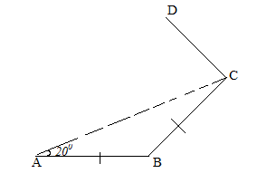

*Find the:*

1. *Size of each interior and exterior angle of the polygon.*
2. *Number of sides of the polygon.*

***Solution***

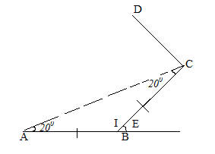

1. *I+200+200=1800*

*I=1400*

*Also, E=200+200=400.*

1. *Each exterior angle=*

*=400*

*n=9.*

***METHOD II***

*Each interior angle=*

*=1400*

*n=9.*